Poetry Seminar
Written Submission Guidelines

The Kinkos-bound packet/book should contain the following:
- Cover Sheet
- Table of Contents
- Detailed Lesson Plan
- Section detailing the movement’s history
- Mini Biographies
- Poetry Explications
- Original Poetry
- Bibliography

Cover Sheet

The cover sheet essentially serves as your book cover. It will be visible behind Kinko’s clear plastic cover. Your cover should include your book title. The names of all group members should also be included. A sample cover sheet is included with this handout.

Table of Contents

The Table of Contents tells the reader quickly and clearly how your thesis is organized. Whether you list only main headings or provide a detailed listing of headings, the Table of Contents must be neat and accurate. Show a page number on all Table of Contents pages, and a main “TABLE OF CONTENTS” heading on the first page of the Table of Contents. Format conventions:

Note:
- Include everything that occurs in your document after your Table of Contents in your Table of Contents.
- Provide the same detail for every chapter (i.e., if you list 2nd and 3rd level headings from one chapter, you must list all 2nd and 3rd level headings that appear in the document).
- Use bold and larger size letters sparingly (e.g., use only for listing main headings).
- Indent lower level headings more than higher level headings; use a different indent for each heading level listed.
- If single spacing is used, leave an extra space above each main (chapter) heading; if double-spacing is used, single space 2-line headings.
- List page numbers in a single column (right-justified); dot leaders are optional, but if used should be used for all listed headings and they must be consistent in style.
- Don’t allow long headings to extend into the page number “column.”
- List the headings using exactly the same wording as you have in the text, but avoid underlining or italicizing headings, regardless of their format in the text.

Example:
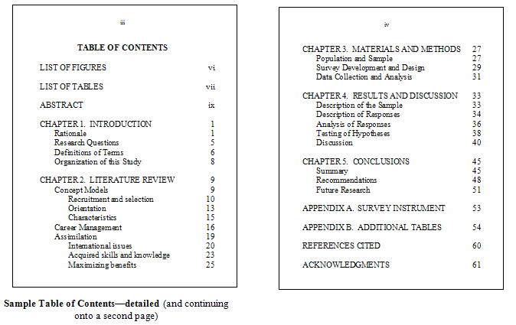

Microsoft Word Hint:
Right justifying listed page numbers in the Table of Contents: With the ruler visible above your text: 1) highlight all the listed headings; 2) manually set a tab every half inch (or closer, if you desire) on the “ruler” until you reach the number “6”; 3) click on the box immediately to the left of the ruler until the symbol “┘” appears; 4) click between the number “6” and the end of the white space on the ruler; 5) insert your cursor after each heading listed and press the tab key until the cursor is at the right edge of the page and type in the page number.

History/Background Section

In completing this section you are essentially answering the questions addressed during the oral presentation. Please ensure that your arrangement of information follows a logical pattern. This section should be informed by 4 scholarly sources.
- Perhaps a brief definition of the movement would make for an adequate opening. The opening for this section could also be rather creative. Allowing a quintessential piece of literature to serve as your introduction to a discussion of the movement is a great idea. Perhaps you have a captivating beginning in mind.
- What are the roots/origins of the movement?
- What social/economic/political stimuli gave rise to the movement?
- What common philosophy/ideology did members share?
- Traits common to the poetry of the movement.
- Prior literary movements that influenced your movement.
- Possible prior literary movements that your movement runs counter to.
- Explore the evolution of the movement.
- This list is certainly fluid and you should feel free to explore and share any other pertinent information that strikes your fancy.
- Were there any critics of your movement? If so, what was the gist of their criticism?
- The legacy of your movement. Meaning, what influence(s) has your subject had on literature/art in general and poetry specifically?

Mini Biography

Each member of the group should write a mini biography on a poet within the assigned school/subject. Some points to touch on (if relevant) would include:
- Details of the poet’s life
- Career and poetry
- Contributions to the literary canon
- Political views
- Later life and honors
- Influence on later poets
(1-2 pages)
* Two scholarly sources
Poetry Explication

Each member of the group should write an explication. Choose a poem that is regarded as one of the preeminent pieces of your movement/subject. Follow the handout for details on poetry explications. (2-3 pages)

Original Poetry

Each group member is then responsible for writing an original piece that honors the movement’s:
- Political ideology
- World view
- Poetic style
- “Heart and Soul”
(Close readings of poetry over the course of this project will make this piece easy. Free yourself here and break free of the confines of traditional prose. Ride the wings of poesy as you allow your mind the freedom to truly ………)

Bibliography

I expect you to follow MLA guidelines in citing sources both within your text and also in your bibliography.

http://library.manor.edu/handouts/manor_mla.doc
http://owl.english.purdue.edu/owl/resource/557/01/
http://www.liu.edu/CWIS/CWP/library/workshop/citmla.htm

The links above thoroughly address MLA citation. The first link is to a Microsoft Word document that goes into great detail. The OWL website also offers up a thorough refresher with the final link presenting the most basic information.

Final Note:

The final product should reflect extensive research, thorough understanding of the poetry and the respective movement, acute awareness of even the most minute detail in the presentation of the “book.” Wikipedia is unacceptable; JStor is acceptable! Among other things, this is an exercise in scholarship.

